UNDER WATER OPTICAL WIRELESS COMMUNICATION
ABSTRACT
Underwater wireless information transfer is of great interest to the military, industry, and the scientific community, as it plays an important role in tactical surveillance, pollution monitoring, oil control and maintenance, offshore explorations, climate change monitoring, and oceanography research. In order to facilitate all these activities, there is an increase in the number of unmanned vehicles or devices deployed underwater, which require high bandwidth and high capacity for information transfer underwater. Although tremendous progress has been made in the field of acoustic communication underwater, however, it is limited by bandwidth. All this has led to the proliferation of underwater optical wireless communication (UOWC), as it provides higher data rates than the traditional acoustic communication systems with significantly lower power consumption and simpler computational complexities for short-range wireless links. UOWC has many potential applications ranging from deep oceans to coastal waters.
KEY WORDS: Underwater optical wireless, optical beam propagation, visible light, radio frequency, acoustic communication, hybrid optical-acoustic system, modulation and coding.

HARDWARE REQUIREMENTS:
- Arduino uno
- Lasers
- Voltage Regulators
- 12V Transformer
- Photo diodes
- 1000UF capacitor
- Diodes
- Transistors
- 3.5 mm Audio jack
- Audio amplifer circuit
- Speaker
- LCD
- USB or PS-2 Key board
SOFTWARE REQUIREMENTS:
- Arduino IDE software
- Embeded c
ADVANTAGES:
- High Bandwidth
- It avoid data spoofing
DIS-ADVANTAGES:
- Point to point communication
- Propagation delay

BLOCK DIAGRAM
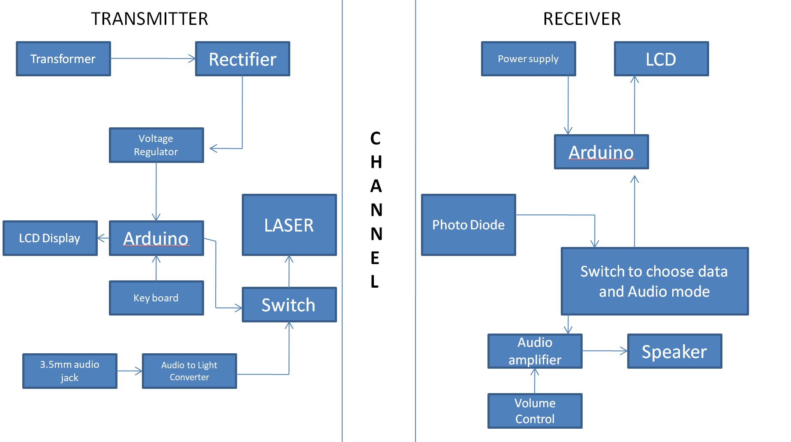
Project members:
S.no | Student name | Roll Number | Signature
1 | V.Hema Sri | 20MQ5A0443
2 | K.Anka Himanya | 20MQ5A0415
3 | D.Suresh | 20MQ5A0424
4 | V.Sasi Varma | 19MQ1A0429

signature of project guide

